How to start a packing hub

The Wellington Fruit and Vegetable Co-operatives started as a pilot in May 2014. It is a partnership with Wesley Community Action and Regional Public Health. The aim is to improve the affordability and access to fresh fruit and vegetables for communities in low socio economic areas. Fruit and Vegetable Coops belong in their communities, for the community. We seek to work within a community led development model.
Becoming a packing hub is effectively becoming a co-op within the wider co-op.

How the Co-ops work
People prepay either $12/$15 at their local distribution centre (e.g. school, church, kindy, community centre, packing hub).
The distribution centres bank their money or arrange internet banking with the packing hub and email/text the packing hub the number of orders it has been paid for by 5pm Thursday each week.
Each packing hub then contacts the Wesley Community Action Regional Coordinator with the total number of orders for that packing hub by 9am Friday.
The Regional Coordinator processes the weekly buy with MG Marketing on behalf of all the packing hubs. Currently this happens on a Friday, Monday and delivery is on a Tuesday/Thursday.
The produce is then collected by the transport company we partner with and freighted to each packing hub on the Tuesday/Thursday morning of the pack. Volunteers at the packing hub then pack the produce into bags. This takes about 2 hours from set-up to the end of the clean-up on average.
The various distribution centres then come and collect their orders from the packing hub. People then collect their pre-paid packs from their distribution centres often paying for their next week’s order at the same time. Internet banking is also available at a number of Hubs.

What you need to run a packing hub
Bank Account
Distribution centres will pay into this and invoices for produce, bags and freight will be paid out of this.
Account with MG Marketing
Here is the link for the Buyer Application Form and the Buyer Terms and Conditions:
http://mgmarketing.co.nz/web/guest/terms-and-conditions

Hall
Ideally the truck can get close to the hall so that there is less distance for your volunteers to transport the produce. Level access to the hall is needed as produce will be on trolleys.
- An initial assessment is to be made by the Regional Coordinator (WCA) to ensure the Hall is suitable for packing.
- An allocated storage space for co-op equipment needs to be negotiated with the venue owner.
- Toilet areas, wash rooms and changing areas must not be used to store food or packaging.

Equipment
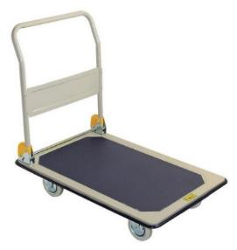
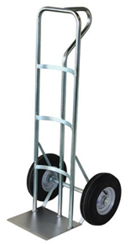
- Trolleys – The platform trolleys are useful for items such as sacks of potatoes and onions as well as the crates. The hand trolleys are best for the crates and work well on rough ground. Here is a contact for top quality trolley http://www.rexproducts.co.nz/.
- Tarpaulins – It makes the clean-up easier if you have a tarp in the middle under all the produce crates. On a wet day a lot of water can be brought into the hall so tarps from the entrance to the central tarp can again save on clean-up at the end of the pack.
- Stanley knife – for cutting open potato bags.
- 2 Kitchen knives – these need to be sturdy enough to cut pumpkins and cabbages in half. An example is: http://www.victoryknives.co.nz/index.php?option=com_content&view=article&id=16&Itemid=49.
- Cut resistant gloves (different sizes) – Those cutting pumpkins need to use a protective glove on their non-cutting hand. Some examples are: http://www.lynnriver.co.nz/our-products/hand-protection/cut-resistant-gloves/pro-comfort-13-gauge/ or http://www.trademe.co.nz/sports/protective-gear-armour/auction-820908129.htm.
- 2 Chopping boards.
- Scales to weigh produce.
- Calculator.
- A box for smaller equipment.
- Signage for each distribution centre and whiteboard marker – a laminated sheet of A4 paper works well.
- Packing tape can be helpful to tape down tarps to avoid tripping.
- Whiteboard and marker to write up the amount of produce for each pack.
- May need cleaning equipment – e.g. brooms, cloths to wipe tables.
- Health and Safety posters and procedures produced by Regional Public Health.

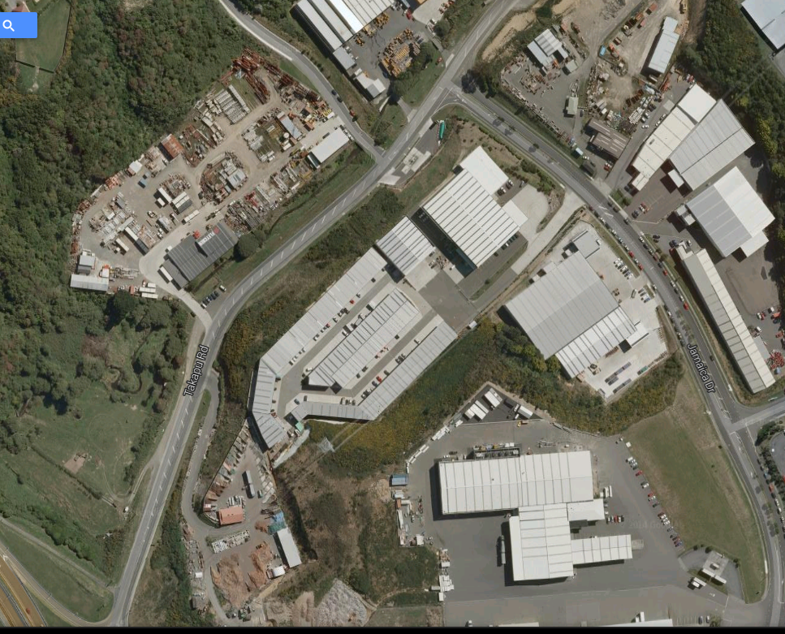
SH1 – Tawa Off ramp
Fresh Direct
MG Marketing

Breakdown of the $12/$15
- Between $7.00 and $9.00 produce.
- GST from produce spend.
- $55.00/$80.00 + $25.00 crate return is for freight.
- $1.00 is a levy for Wesley Community Action infrastructure and Regional Public Coordinator role.
- $0.15-$0.60 is for returnable bags. An agreed amount to support the Packing Hubs admin.

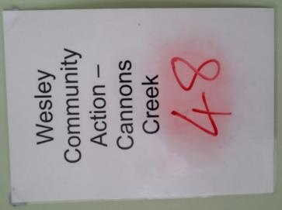
Laminated signs (see image below) are placed around the hall for the various distribution centres with the amount of orders for each one.

Packing
- Truck arrives and is unloaded by volunteers. This involves lifting 20kg crates off the truck and transporting them into the hall on trolleys.
- A volunteer works out how many pieces of fruit and vegetables will go into each bag. This is written up onto a whiteboard for all the packers to see.
- Crates of fruit are placed on one line of tables and vegetables on another line. Bags are passed down the tables and are packed and then placed at the end table for the recipe and health information.
- Bags are then placed on floor of hall ready for collection by distribution centres

Waste Disposal
After the packing there will be cardboard boxes to recycle, plastic to recycle or dispose of, and waste produce to compost.

Crates
The crates and pallets that the produce arrive in needs to be returned to MG Marketing, Grenada North. The packing hub pays $11 for each crate and between $25-29 for each pallet. This money is credited back to your bank account upon return of the crates and pallets. We have an arrangement with ME Transport to collect crates from you and return on your behalf according to what is agreed.

Typical process on the day
Hall set-up
Here is a suggested hall set-up:
Vege Line
Fruit line
Crates from truck stored here
Packed bags placed in rows on floor for the distribution centres to collect
Recipe and health info put in packed bags.

Systems
You will need good accountable systems around money to ensure that distribution centres get the right number of orders.
- It can be helpful to have a small window for the pick-up of orders by the distribution centres. This ensures that the hall is cleared out so that the clean-up can occur.
- Storage is only temporary for produce. In general product arrives and leaves the packing hub in 24 hours.
There is always some surplus produce left after the packing. Our only recommendation is that you are transparent with volunteers and the distribution centres about what you do. There are many possibilities. In Porirua the surplus is given to a local foodbank. Other possibilities could be making a soup for the volunteers, selling it at a reduced rate to people picking up their packs, or giving it to a different distribution centre each week.

Volunteers
Ideally you will have 10-12 volunteers. You can do it with less when you have less than 100 orders. Beyond 100 orders the packing will go quicker if you have all the positions filled. Ideally you will need the following numbers:
- 4 on the fruit line and 4 on the vegetables
- 1 strong person in the middle keeping the tables loaded and breaking down cardboard boxes.
- 1-2 inserting fliers and lying packed bags out in hall.
- Ideally the coordinator of the packing hub is able to float and trouble shoot.
You do need some strong people for the unloading of the truck.
- Volunteers need to sign the volunteer registration form. A register of volunteers need to be maintained.
Account with a freight company
We have a brokered arrangement with ME Transport, well below market rates.
The truck driver will need your MG Marketing buyers’ code when they collect your produce. The Regional Coordinator is able to set this account up for you.

Health and Safety
There are some significant Health and Safety issues that will need managing:
- Heavy lifting – 20 kg crates need to be manually lifted off the trucks and taken into the halls. Volunteers will need to be educated about good lifting techniques and ideally only the fittest and strongest perform this role.
- Level access to hall - ideally need places with wheelchair access due to the need for sack barrows.
- Safety with knives – education of volunteers and use of cut resistant gloves
- Traffic management to support trucks parking (if needed) – education of volunteers and use of reflective vests.
- Hand hygiene – use of hand sanitizer
- Volunteer health – no food handling if a volunteer is unwell
Volunteers will need to be screened by the coordinator so that their role is matched with their physical ability (See Appendix 1). The coordinator may send home any volunteer they consider to be too unwell to pack.

Appendix 1 – Example of a volunteer health and safety screening form

Volunteer Registration Form

Name:

Address:

Phone:

Date of birth:
(so we can celebrate with you on your birthday week!)

Emergency contact:

Phone:

We want to keep everyone safe while they are working at the Co-op packing hub. Tasks at the packing hub include:
- Standing for up to 2 hours
- Heavy lifting (20kg crates)
- Repetitive movements packing produce
- Occasional use of knives to chop produce (e.g. pumpkins)

To make sure we don’t ask you to do jobs that will be unsafe for you we need to know the following:

- Have you ever injured any part of your body? If so, which part?

- Do you have any ongoing health issues or conditions that would affect your ability to perform the tasks of the packing hub?

- Have you read and do you understand our Health and Safety guidelines?

- Please let talk to the Hub Coordinator if there is anything you feel unsafe doing. We can find another job for you to do.
- You will need to turn up to each pack clean and well, and with covered toe shoes.

